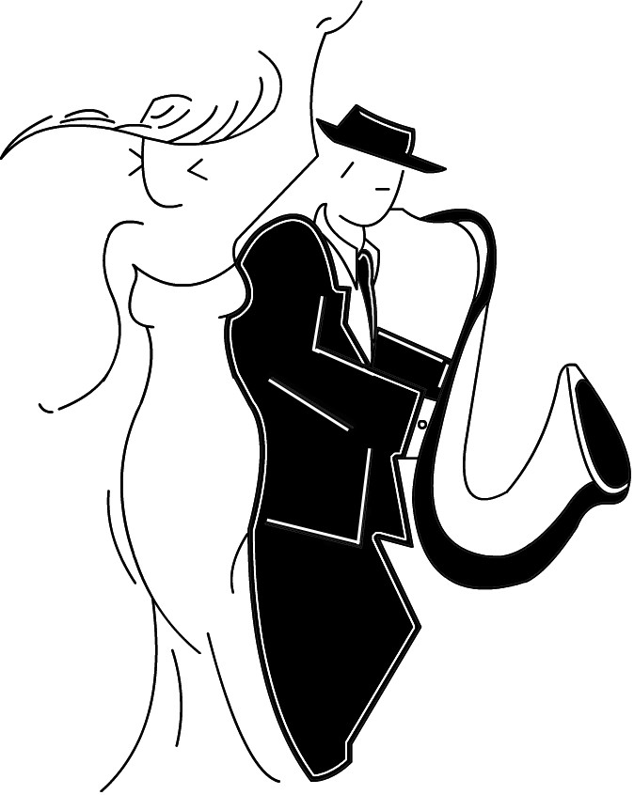

**JLSM Modeling**

“Where Everyone Is a Model”

**JSLM Talent Contract**

*As a talent, it is our desire for you to reach your God-given potential and to be the very best you’re capable of being as a person, student, and talented one. You have a significant role in the success and growth of yourself. By initialing after each item and signing below, you are agreeing to uphold the following standards and rules*:

1. I will take pride in myself, what I stand for, and who I represent at all times, on and off the stage. I am now a

member of JLSM! I understand my choices reflect back on this organization. ____

2. I will always work to improve myself. _____

3. I will never disrespectfully question the instructor –I will respect the techniques at all times. ___

4. I will always expect good things to happen and have a positive attitude in practices and events. _____

5. Practice doesn’t make perfect; perfect practice helps me master the talent faster. _____

6. I will treat my parents, instructors, other talents, and guests with respect at all times. ____

7. I will allow my instructor to cretic me and help me make the appropriate enhancements if needed for growth in

the industry or with the goals I am working on. ______

8. I will use *my* voice to talk to my instructor when I don’t understand something about time, skill development,

starting roles, or any other concerns I have about myself and my role with JLSM. My parents will not fight my

battles for me. Speaking up for myself is an important skill for me to learn in life. Competition will make me

and my entire team better! ______

9. I will dress appropriately, as if I am going to church.

10. I will remember there is always someone out there who is practicing their skills when I am taking a break. If I

want to be the best, I must practice on my own. I am the only one who puts limits on myself when it comes to

my development of my individual skills. Therefore, I will spend extra time working on my weaknesses so I can

become a better talent. _____

11. I will always maintain a positive, open mind toward my instructors. _____

12. I will attend all practices and events. If I cannot do so, then I will inform my instructor by email, phone, or

text BEFORE the practice or event. **This is MY responsibility, not my parents! ____**

13. I will allow all footage of events and workshops to be used for promoting my talent and the company.

Talent’s Name: ___________________________________________________ Grade: __________

Talent’s Signature: __________________________________________________________________

Parent/Guardian Signature: ___________________________________________________________